# CSB – Website Assignment

The goal of this assignment is for you to make a **professional** website from scratch using HTML and CSS.

### Your website must have:

* A main topic of your choice.
* 10 pages.  
  Make content for each of them.  
  All of the pages in your site should be on-topic.  
  At least 5 of these pages must be in the menu that appears on all pages.  
  Your menu may have horizontal or vertical orientation. Either is fine.
* One of your 10 pages must be the Homepage.  
  The file **must** be called **index.html**Your homepage must have (at least):
  + Your name
  + Period #
  + Introduce the topic of the site
    - 2 paragraphs of text
    - 2 pictures
* One common design template (ie: Templates/main.dwt like we made in class)  
  All 10 pages should use this.  
  To create another page, use File – New – Site Templates, and choose main.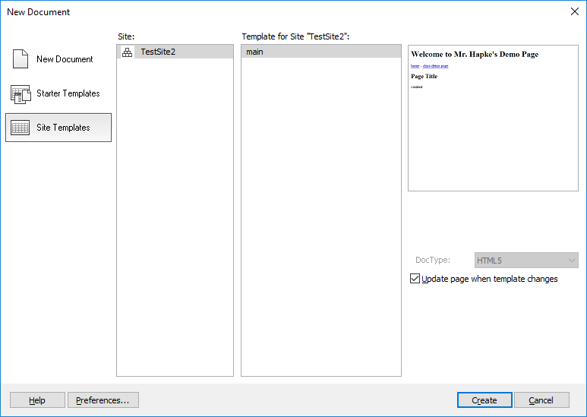
* One common CSS style sheet (ie: style/hapke.css like we made in class)   
  In your main template’s <head> you should have:  
  <link rel="stylesheet" type="text/css" href="style/hapke.css" />  
  All 10 pages should use this.  
  All style choices: (ie: font colours, font sizes, div widths, etc. MUST be made in the stylesheet)
* Appropriate choice of background colours/graphics.  
  The site should be professional, with gentle graphics, not obnoxious.  
  Some colour/gradient/gentle texture is wonderful; your page shouldn’t be drab and totally lame!  
  Overbearing animations and obnoxious colour choices are unacceptable!
* At least 5 images.  
  Put them in the images folder.  
  ex: <img src=”images/filename.jpg” alt=”text description” />
* At least 1 table.  
  <table> to start  
  <tr> for each row  
  <td> for each cell
* At least 3 custom styles (ie: like div.important) in the stylesheet.   
  You should be using these with the class option.  
  ie: <div **class**=”important”> or <p **class**=”bordered”>
* At least 1 **U**n-ordered **L**ist (ie: bullets)  
  <ul>
* At least 1 **O**rdered **L**ist (ie: numbering)  
  <ol>
* For lists (both ordered and un-ordered), you will need to use <li> for each **L**ist **I**tem.

### Your website must NOT have:

These choices must be made using the stylesheet:

* <font> tags
* <body **background**=”…”>  
  or  
  <body **bgcolor**=”…”>

### Marks:

I’ll add the rubric to the website over the next couple days.